Homework 9. Quantitative Methods for fixed Income Securities

13.1 Build a 3-period interest-rate tree under the Ho-Lee model, with parameters 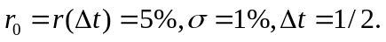 Determine the drift 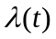 according to spot rates 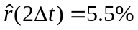, 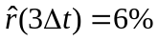 and 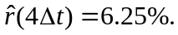 Keep the branching probabilities to be {1/2,1/2} all along.
13.2 [Continued from 13.1] Price a call option on 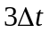-maturity zero-coupon bond with face value $1,000. The maturity of the option is 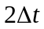and the strike is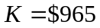. Explain how to hedge the option.
13.3 [Continued from 13.1] Price a CMT swap with cash flows
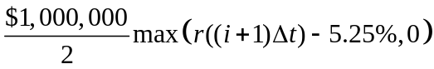
that occur at times 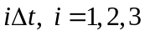.
The following data as of May 15, 2001, relates to the old 10-year Treasury bond and the on-the-run 10-year Treasury bond.
Overnight
Coupon Maturity Yield Price Repo Rate DV01
5.75% 8/15/2010 5.4709% 101-31⁷/₈ 3.80% .07273
5% 2/15/2011 5.4346% 96-23+ 0.10% .07343
15.1 Calculate the carryover one day for $100 face of each of these bonds and comment on the difference. Note that there are 89 days between May 15, 2001, and August 15, 2001, and 181 days between February 15, 2001, and August 15, 2001.
15.2 Calculate the return to an investment in each bond if their respective yields fall by one basis point immediately after purchase.

